CRISPR/Cas9 Synergistic Activation Mediator (SAM) pooled human library

CRISPR/Cas9 Synergistic Activation Mediator (SAM) is an engineered protein complex for the transcriptional activation of endogenous genes. It consists of three components:

- A nucleolytically inactive Cas9-VP64 fusion,
- An sgRNA incorporating two MS2 RNA aptamers at the tetraloop and stem-loop 2
- The MS2-P65-HSF1 activation helper protein.

SAM can be combined with a human genome-wide library to activate all known coding isoforms form the RefSeq database (23,430 isoforms) for gain-of-function screening.

Library description: The SAM library consists of 3 unique sgRNAs targeting each human RefSeq coding isoform in the proximal promoter (> 90% of sgRNAs are targeted to the first 200bp upstream of the TSS of their target). The total library size is 70,290 guides. For SAM gain-of-function screening, this sgRNA library has to be combined with two additional SAM constructs – dCas9-VP64 and MS2-P65-HSF1. These are provided along with the library.

Screening: After amplification of the library DNA according to the provided protocol, lentivirus is produced for the library, dCas9-VP64 and MS2-P65-HSF1 separately. The design of the three lentiviral vectors is shown below:
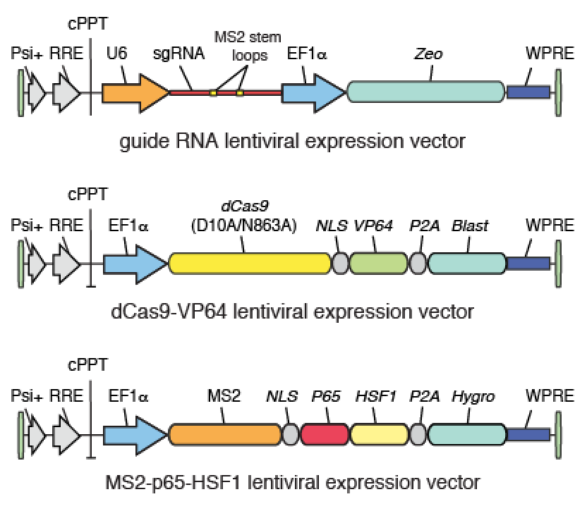

The Lentivirus of all three components is then titrated and target cells are transduced with dCas9-VP64 and MS2-P65-HSF1 at MOI <1 and selected with Hygromycin and Blastcidin for 5-7 days. After complete selection, cells are transduced with the sgRNA library at an MOI of 0.2. It is important to maintain sufficient representation of the library from here on. We recommend to transduce and maintain >500 cells per guide in the library. This equals >175 million cells for the initial transduction and maintenance of > 35 million cells after completed selection with Zeocin. After 7 days of selection with Zeocin, cells are ready for screening to begin.

Cells have to be transduced with all three SAM components.

